**1.Abstract**

Crude oil is the key commodity for the global economy because it is the most important strategic resource on the planet. As a result, forecasting it has been a difficult task because many events influence its price, making it difficult to forecast its prices. The price of crude oil is subject to high volatility and fluctuations. Many studies have recently been conducted to discuss the problem of predicting oil prices and obtaining the best results. Forecasting its requirements will be beneficial to our government, businesses, and investors. This project entails developing artificial neural networks (ANN) to forecast crude oil prices. In this project, we propose a novel aritficial approach to crude oil price prediction.

**Keywords**: Crude oil, economy, energy, fuel, price.

**2.Litreature Survey**

**2.1 Application of Traditional and Statistical Econometric Models:**

Among the numerous forecasting models developed to forecast the price of "black gold," traditional statistical and econometric methods were the first to be used by academic researchers. Amano proposes the first study on forecasting the oil market (1987). For oil market forecasting, the author employed a small-scale econometric model. In the 1980s, Huntington (1994) used a sophisticated econometric model to forecast oil prices. Gulen (1998) used cointegration analysis to forecast the WTI crude oil price in another study. To forecast oil prices, Barone-adesi et al. (1998) proposed a semi-parametric approach based on the filtered historical simulation technique. Morana (2001) used a semi-parametric approach based on the GARCH properties of oil price volatility, which was investigated by Barone-adesi et al (1998) to Brent crude oil price forecast in the short term Tang and Hammoudeh (2002) used a nonlinear regression to forecast OPEC basket prices. Ye et al. (2002, 2005) used OECD petroleum inventory levels and relative stock inventories to develop a simple linear regression model for short-term monthly prediction of WTI crude oil spot price. In a related study, Ye et al. (2006) added nonlinear variables such as low- and high-inventory variables to the linear forecasting model proposed by Ye et al. (2002, 2005) to predict WTI crude oil prices in the short run. Zamani (2004) used an econometric forecasting methodology to forecast the quarterly WTI crude oil spot price using OECD stocks, non-OECD demand, and OPEC supply. Lanza and colleagues (2005)

analysed crude oil and product prices using error correction models Sadorsky (2006) forecasted daily volatility in petroleum futures price returns using multiple univariate and multivariate statistical models such as GARCH, TGARCH, AR, and BIGARCH. Dees et al. (2007) developed a linear model of the global oil market to predict oil demand, supply, and prices, with a focus on OPEC behaviour. Murat and Tokat (2009) investigated the relationship between futures and spot crude oil prices, testing futures prices' ability to forecast spot price movements using a random walk model. Cheong (2009) forecasted crude oil markets using ARCH models.

Recent studies, on the other hand, have used GARCH as well as various GARCH family models to predict oil prices. For example, Narayan and Narayan (2007) and Agnolucci (2009) forecasted spot and futures crude oil prices using the GARCH model. Mohammadi and Su (2010) conducted a related study in which they compared the forecasting results of various GARCH-type models in order to predict the crude oil price. Kang et al. (2009) proposed CGARCH, FIGARCH, and IGARCH models to forecast crude oil market volatility.

Wei et al. (2010) extended Kang et al. (2009)'s study by using linear and nonlinear GARCH-class models for the same purpose. The application of linear techniques revealed a significant difference between actual and predicted oil prices. Several exogenous variables have been used in these models to predict oil prices; however, inventory, supply, and demand are the most commonly used factors. Because supply and demand are relatively inelastic to price changes, inventory adjustments can be slow, explaining a large portion of the difference between real and forecasted prices, particularly in the short run (Hamilton, 2008).Traditional statistical and econometric techniques, on the other hand, are typically only capable of capturing linear processes in data time series (Weigend and Gershenfeld, 1994). However, the behaviour of oil prices is characterised by a high degree of nonlinearity and irregularity. As a result, the models mentioned above are not suitable for forecasting the oil price.

**2.2 Artificial Neural Network (ANN):**

**2.2.1 Definition and Neuron Model Evolution**

**2.2.1.1 Definition**

ANN is an input-output mathematical model inspired from human brain functioning by adopting the same mode of acquiring knowledge through learning process. Fig. 1 summarizes an analogy between biological and artificial neuron.

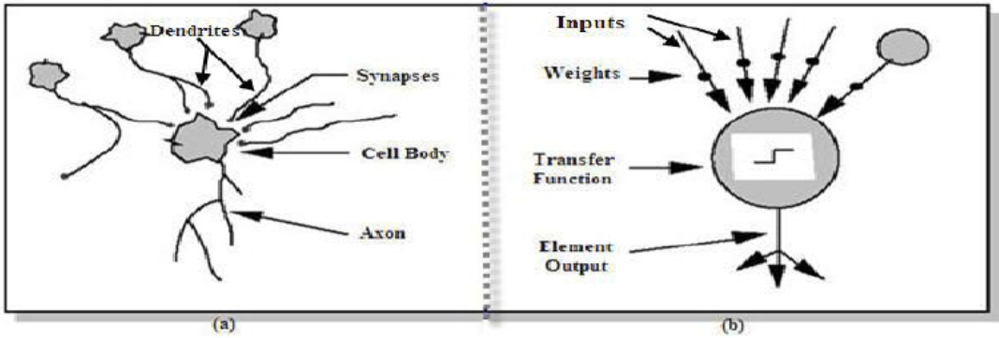

**Figure 1. Analogy between biological neuron (a) and artificial neuron (b)**

**2.2.1.2 Neuron Model Evolution**

**a) McCulloch & Pitts (1943) neuron model**

Neuron model by McCulloch and Pitts (1943). The first artificial neuron, also known as a formal neuron, was proposed by McCulloch and Pitts (1943). The McCulloch-Pitts neuron model can be expressed mathematically as follows:

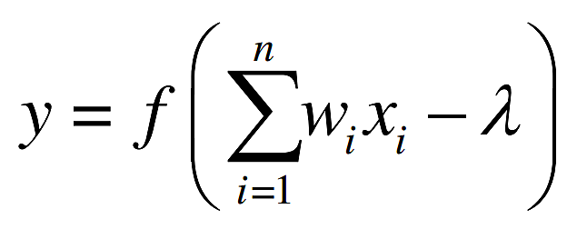

Where 1 2 x , x , ..., n x represent the McCulloch-Pitts neuron inputs that are exclusively binary values (zeros or ones), 1 2 , ,..., w w wn are the connections‟ weights received by the neuron. f is the sign function,  is the threshold and y is the output of McCulloch-Pitts neuron defined as:

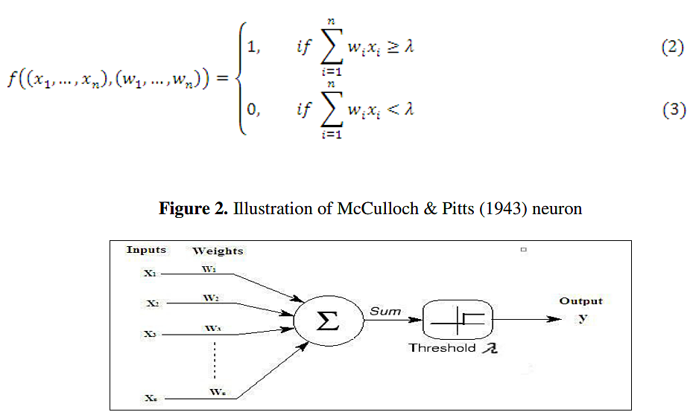

**b) Multilayer perceptron model**

Perceptron neural nets with no hidden layers assume only binary input-output values and only two layers, which explains the model's ability to treat only linearly separable functions. Windrow and Hoff (1960) propose the delta rule, which consists in modifying the weights of the connections in order to reduce the difference between the desired and actual output value. As a result, instead of 0 and 1, the output value can take any value.

In their book, Minsky and Papert (1969) emphasised the utility of adding one or more hidden layers to detect the complex features present in the inputs. Traditionally, the multilayer perceptron net was trained using Rumelhart et albackpropagation .'s learning algorithm (detailed in the following section) (1986). A multilayer perceptron is made up

of an input layer, one or more hidden layers, and an output layer (see Fig .4).

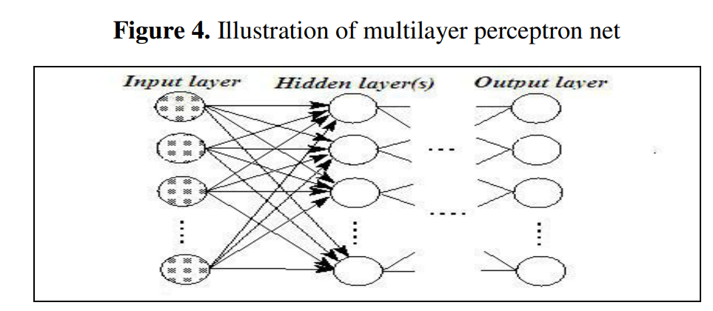

The information propagates in this network system in a single direction„„forward: the input units pass the information to the neurons in the first hidden layer, the outputs from the first hidden layer are then passed to the next layer, and so on. As a result, the network output (for example, with one hidden layer) is as follows:

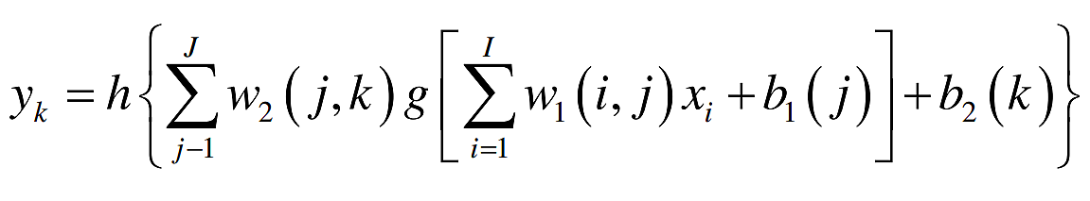

Where: I x are the network's input variables; I is the number of input variables; J is the total number of nodes in the hidden layer; K is the number of neurons in the output layer; g and h are the transfer/activation functions of the first and second layers, respectively; w1 is the hidden layer's weights matrix; w2 is the output layer's weights matrix; 1 b and 2 b are the bias vectors of the hidden layer and It should be noted that at least one transfer function (described further in the following section) of the hidden layer must be nonlinear (Hornik et al., 1989).

**References:**

[1] Yu Runfang, Du Jiangze and Liu Xiaotao, “Improved Forecast Ability of Oil Market Volatility Based on combined Markov Switching and GARCH-class Model, Procedia Computer Science, vol. 122, pp. 415-422, 2017.

[2] K. Greff, R. K. Srivastava, J. Koutník, B. R. Steunebrink and J. Schmidhuber, "LSTM: A Search Space Odyssey," IEEE Transactions on Neural Networks and Learning Systems, vol. 28, no. 10, pp. 2222-2232, Oct. 2017.

[3] Mohammad Reza Mahdiani and Ehsan Khamehchi, “A modified neural network model for predicting the crude oil price”, Intellectual Economics, vol. 10, no. 2, pp. 71-77, Aug. 2016.

[4] Manel Hamdi and Chaker Aloui, "Forecasting Crude Oil Price Using Artificial Neural Networks: A Literature Survey," Economics Bulletin, AccessEcon, vol. 35, no. 2, pp. 1339-1359, 2015.

[5] Aloui, Chaker & Hamdi, Manel. (2015). Forecasting Crude Oil Price Using Artificial Neural Networks: A Literature Survey. Economics Bulletin. 35. 1339-1359.